EDUCATIONAL ORGANISATION USING SERVICENOW

Team Id: NM2025TMID20011

Team Members: 4

Team Leader: DILLI SREE.G.H

Team Member 1 : HARINI.M

Team Member 2 : OOVIYA.M

Team Member 3 : DEEPALAKSHMI.N

Problem statement:

Objective:

Skills:

Educational Organisation Using ServiceNow

The Educational Management System is a comprehensive platform designed to streamline administrative tasks within educational institutions. It facilitates efficient management of student and teacher data, simplifies the admission process, and provides tools for monitoring student progress.
Setting up ServiceNow Instance

- Sign up for a developer account on the ServiceNow Developer site “https://developer.servicenow.com”.

- Once logged in, navigate to the "Personal Developer Instance" section.

- Click on "Request Instance" to create a new ServiceNow instance.

- Fill out the required information and submit the request.

- You'll receive an email with the instance details once it's ready.

- Log in to your ServiceNow instance using the provided credentials.

- Now you will navigate to the ServiceNow.

Creating a Update Set

1. Click on All >> Local update sets .
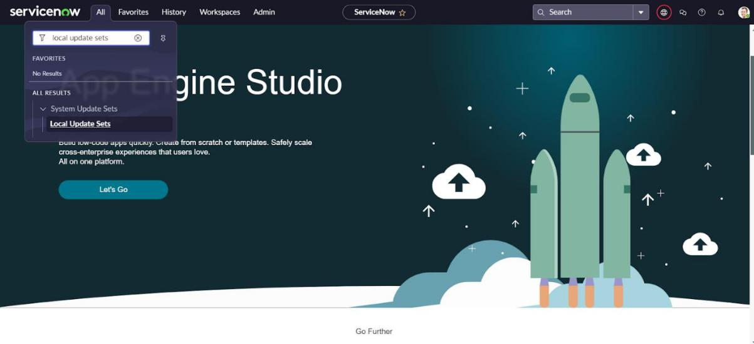

2. Click on new

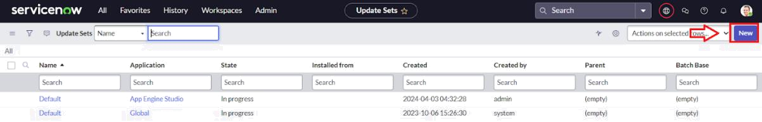

3.Enter the Details Name: Educational Organisation >> Click on Submit and make Current.
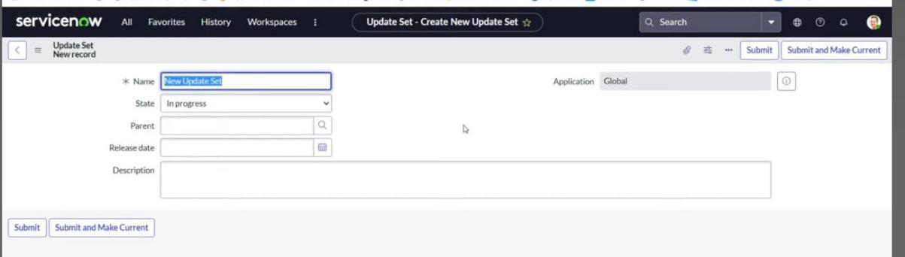

Creating a Table

Creating Salesforce Table.

- All >> Tables.
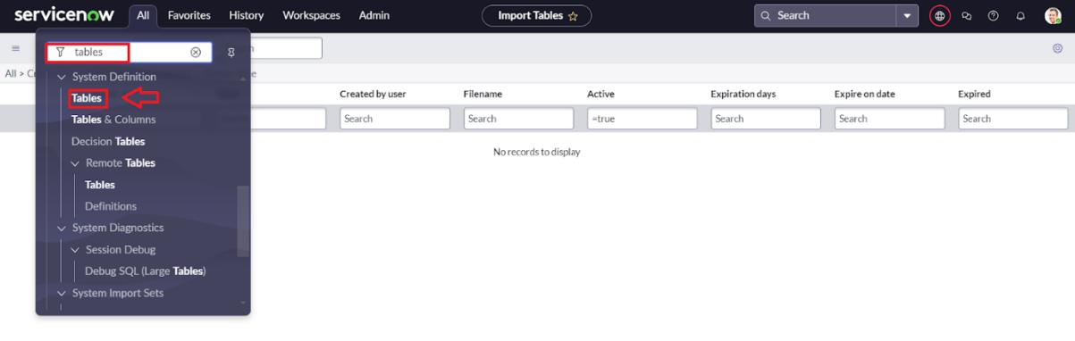
- Click on new
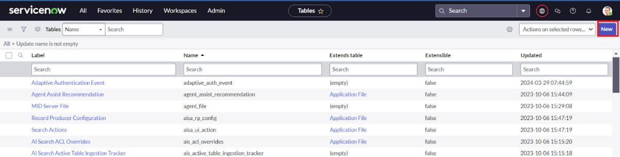

- Enter the Label(Anything you want): Salesforce >> Click on Name it will Automatically generate Api name.
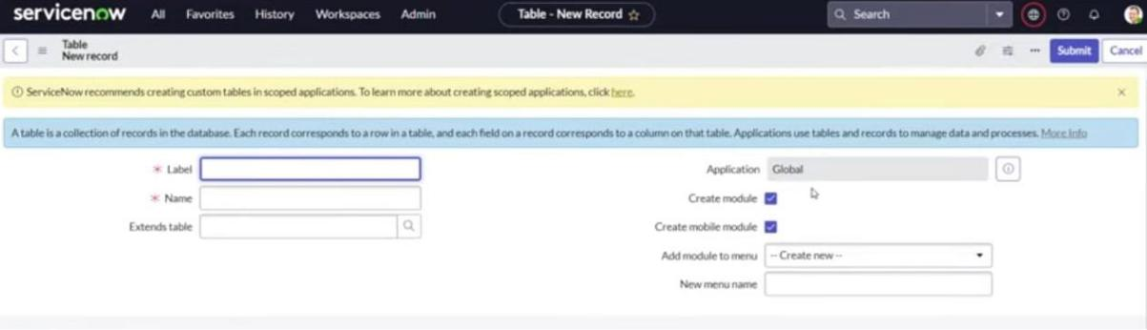

- Create columns as given below,Double Click on Column label and Enter the Column labels and click on the tick mark >> Give Type as given .
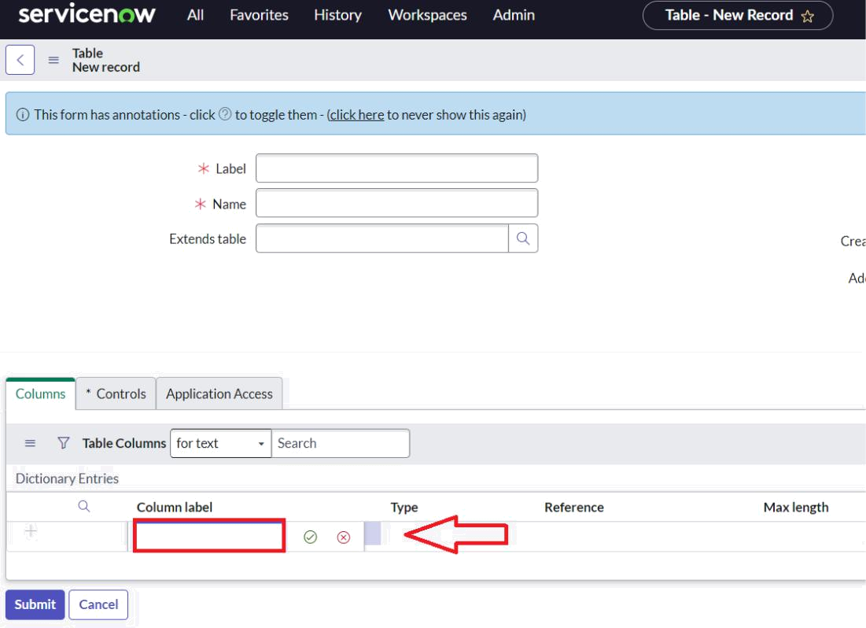

x
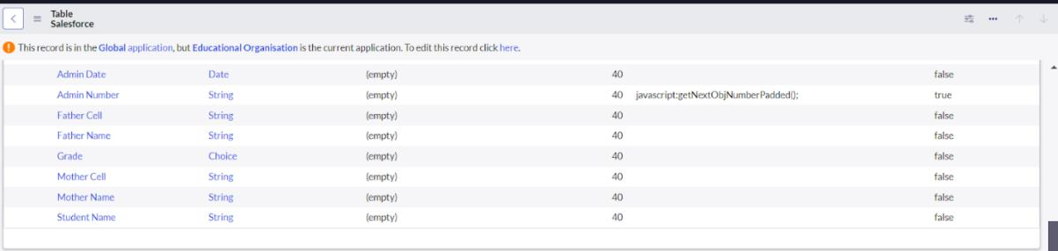

- For “Admin Number” Give Display as True and right click on the toggle bar on top >> save.
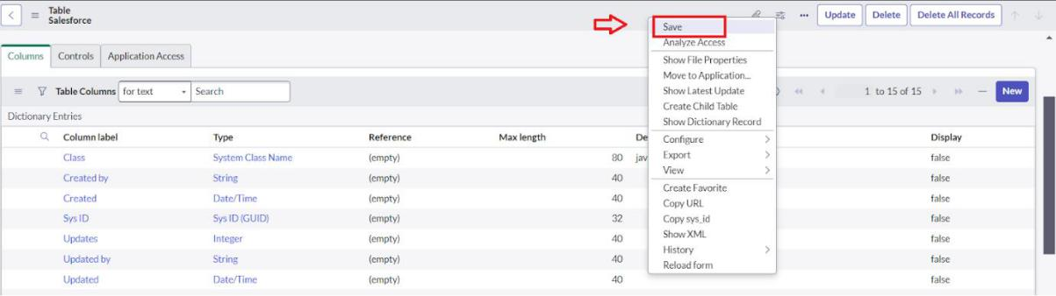
- Click on controls >> Enable Extensible.
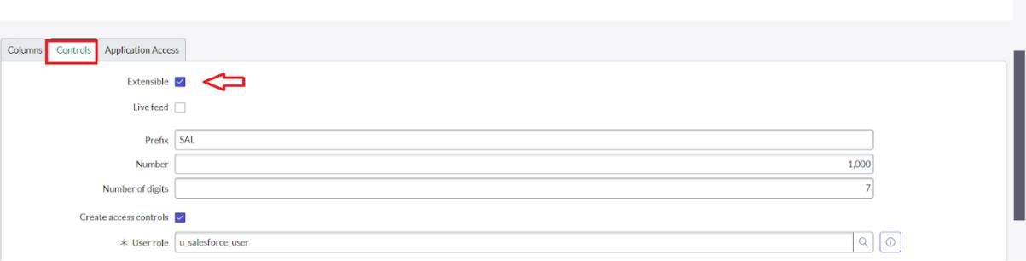

•

- Click on “Admin Number” column, In Related Links Click on Advanced View >> Default View (Enable Use dynamic default) >> select Get Next Padded Number in Dynamic default value >> Update .

- Click on “Grade” Column >> Click on Choices and give Label,Value and Sequence as given below.
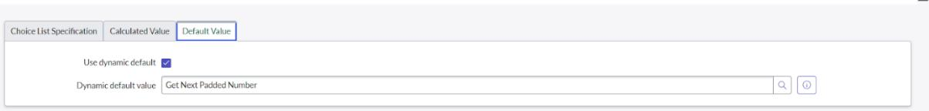
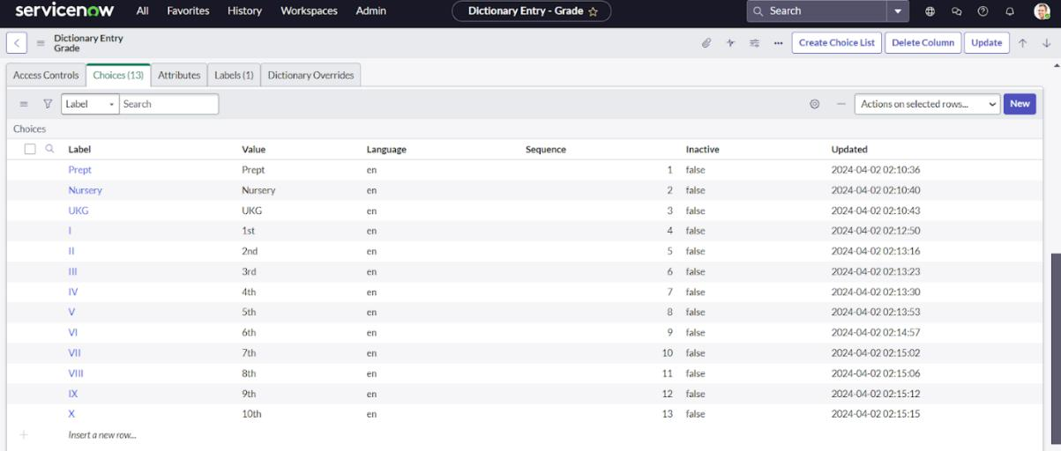

Creating Admission Table

- Create an Admission Table with Columns given.

- Select Extends Table >> Salesforce and also Select Add module to menu >> Salesforce.

- Create Fields as shown
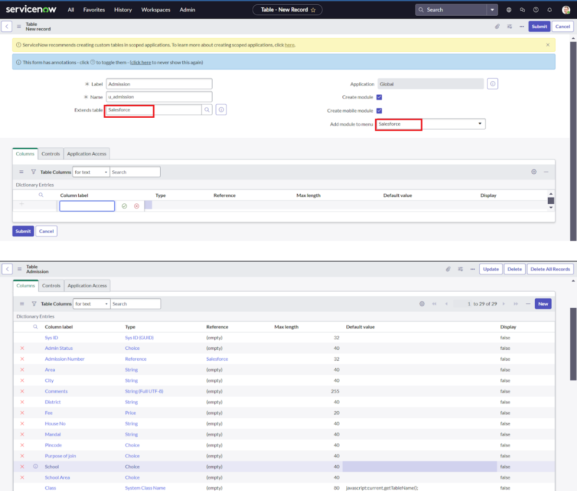

- Create choice for Admin Status as:

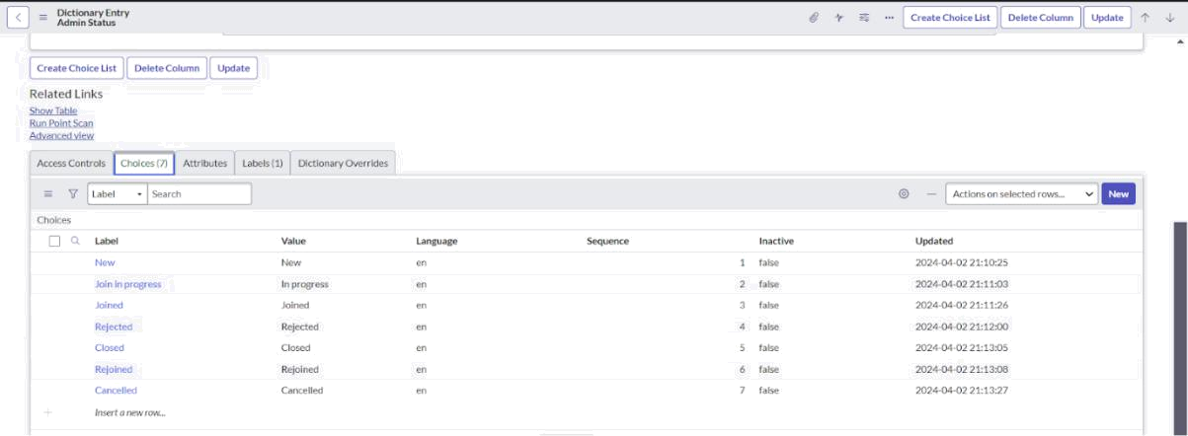

- Create choice for Pincode as:

- Create choice for Purpose of Join as:

- Create choice for School as:

- Create choice for School Area as:
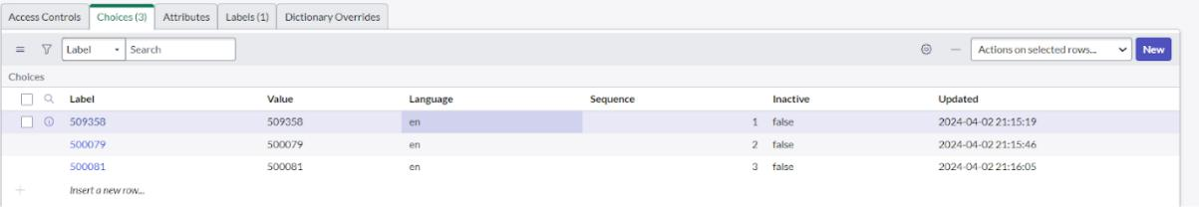
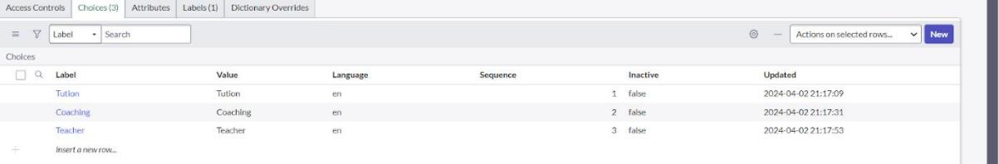
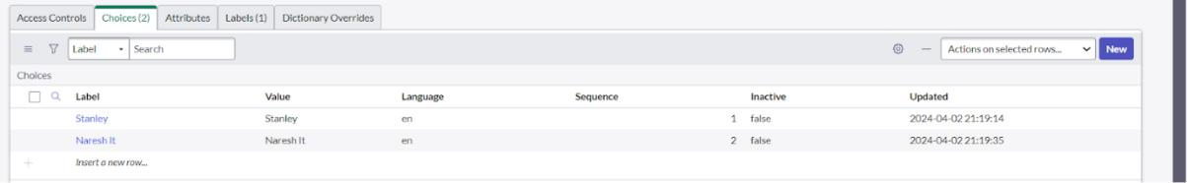
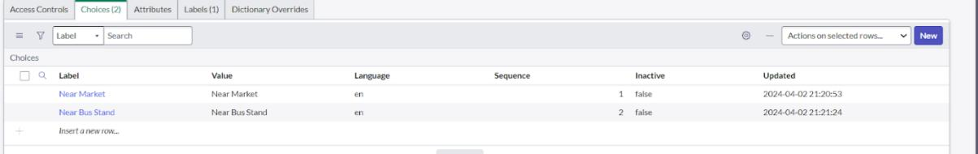

Creating Student Progress Table

- Create a Student Progress Table with Columns given.

- Select Add module to menu >> Salesforce.

- Create Fields as shown:
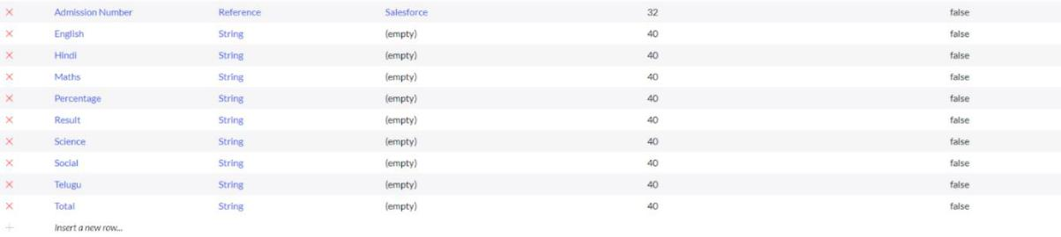

Form Layout

Configuring Table form for Student Progress Table

- In the Student Progress Table Page , Click on Layout form .
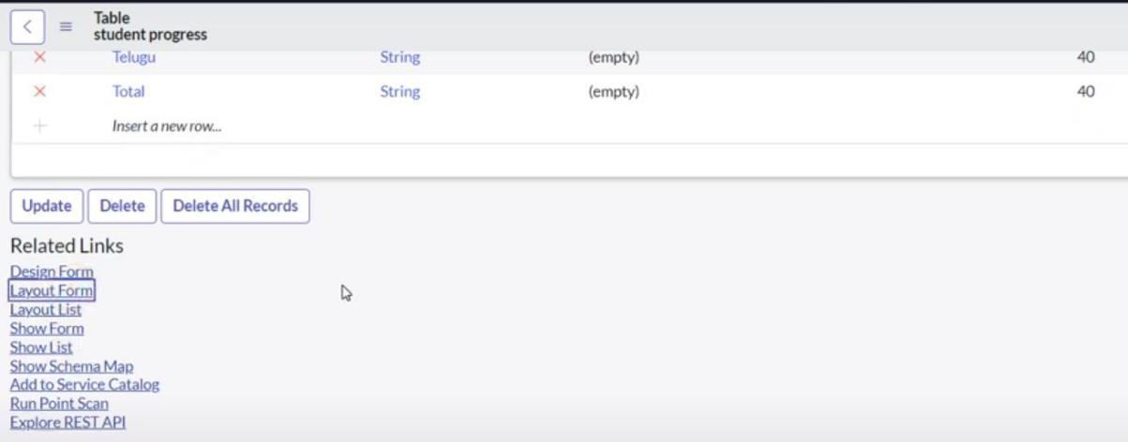

- Click on Admission Number [+] .
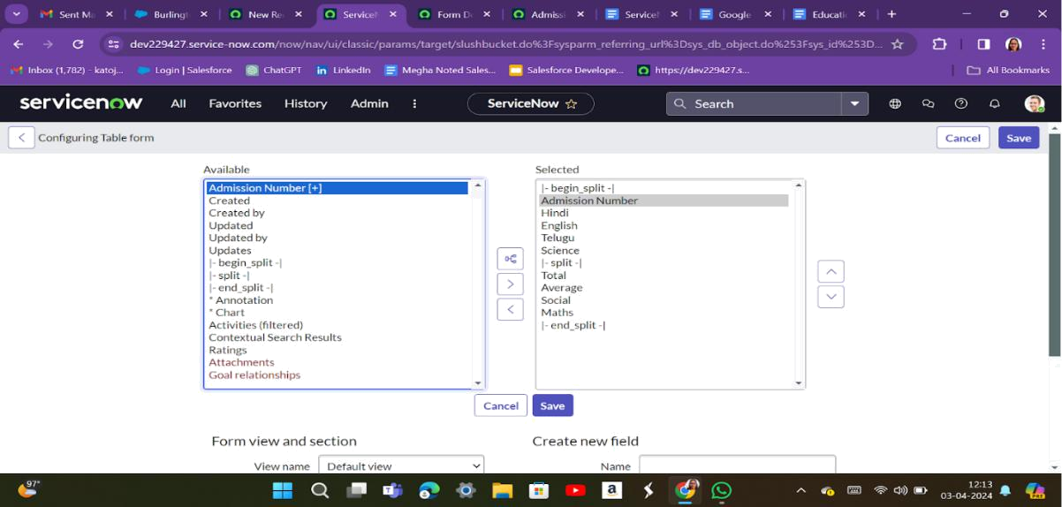

- Select below Admission Number fields in Available side and send it to selected side

as below >> save.

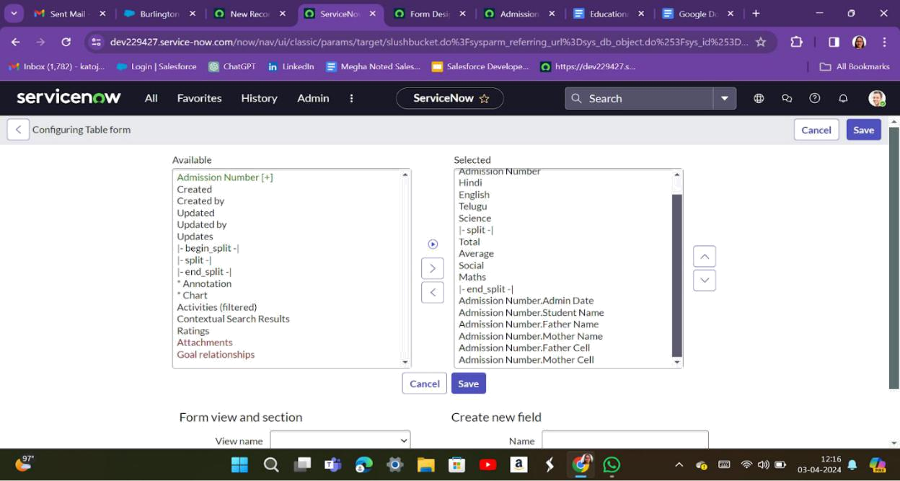

Form Design

Creating Form Design for Salesforce Table

- All >> System Definition >> Tables .

- In Label Search for Salesforce and open .
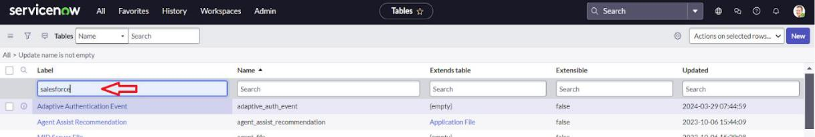

- Right Click on top Toggle >> Configure >> Form Design.
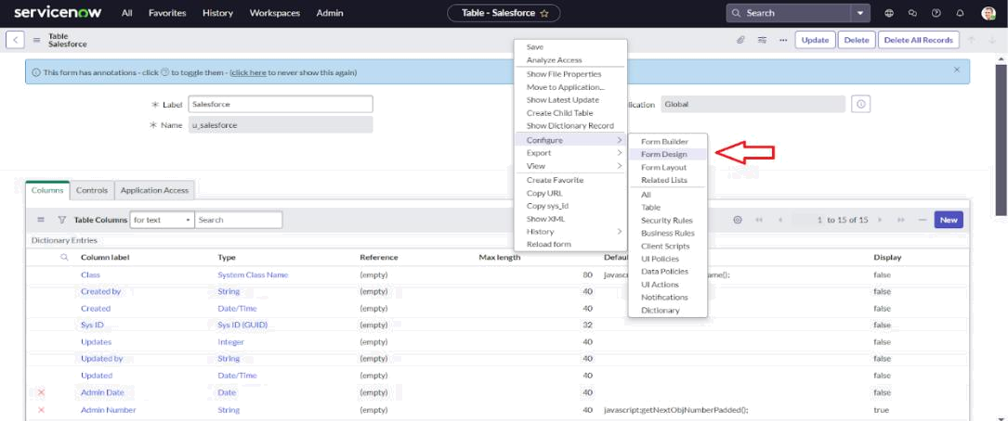

- In drop down select Salesforce(u_salesforce).
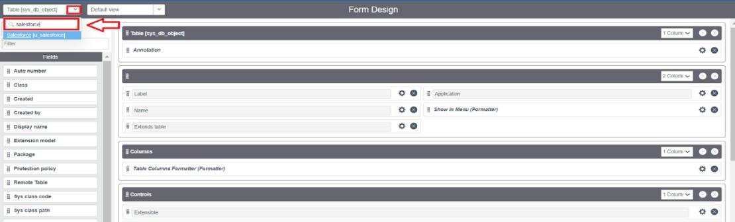

- Drag and drop the fields to the left side as below.
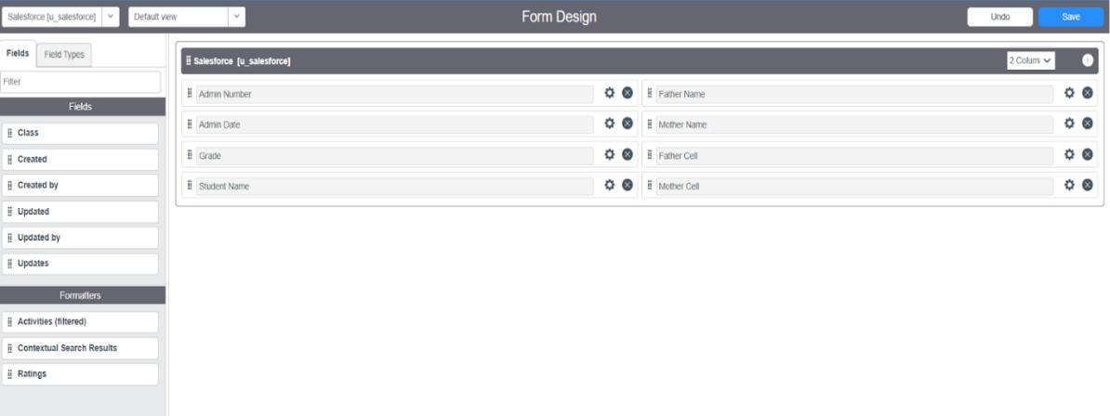

6.Save.
Creating Form Design for Admission Table

Follow the same steps as Activity1,Configure the fields as below and Save.
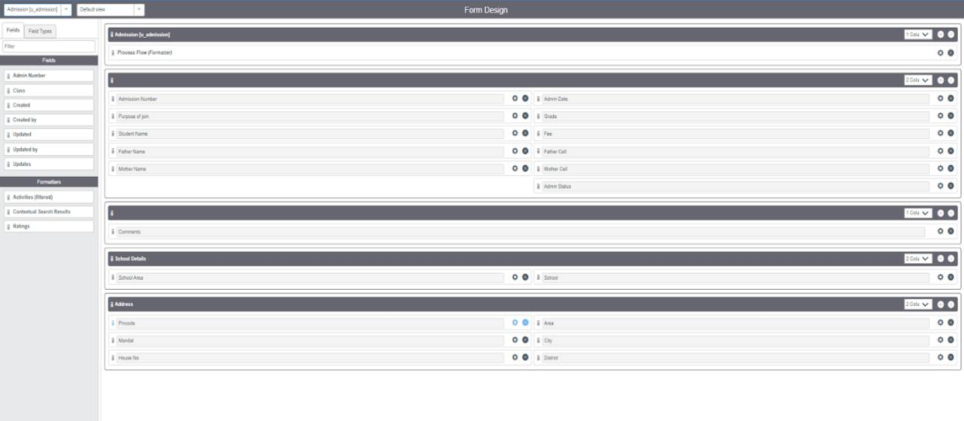

Creating Form Design for Student progress Table

Follow the same steps as Activity1,Configure the fields as below and Save.
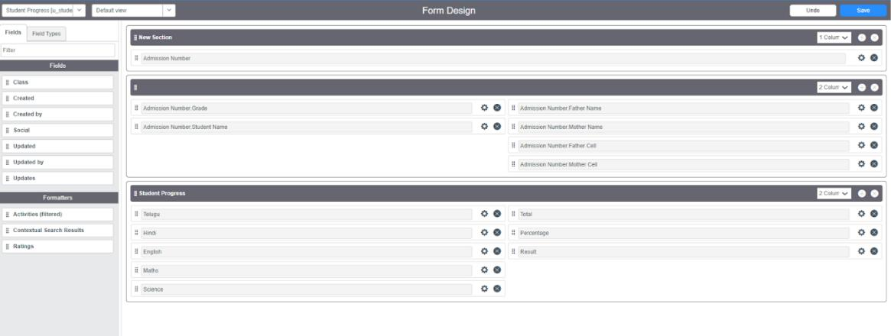
Number Maintenance

Creating Number Maintenance for Admin Number

- All >> Number Maintenance >> New
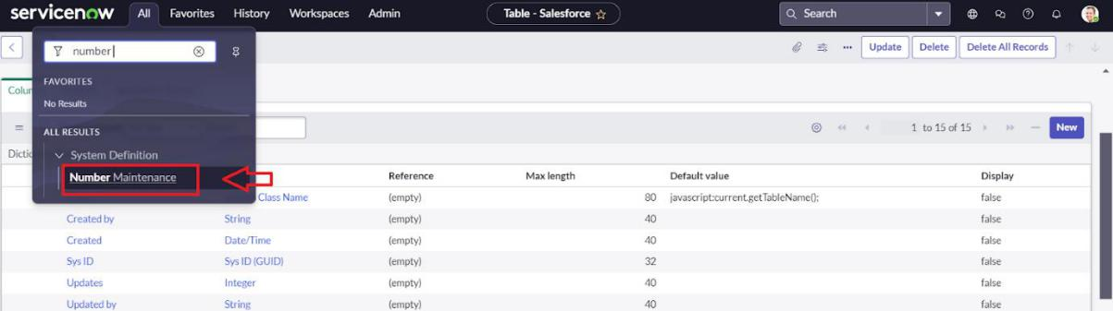

- Fill the details >> Submit.
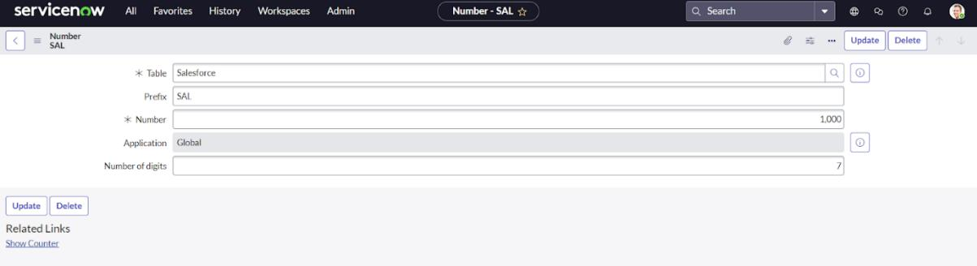

Process Flow

Creating Process Flow for Admission Table

- All >> Process Flow>> New.

- Fill the Details as given Below
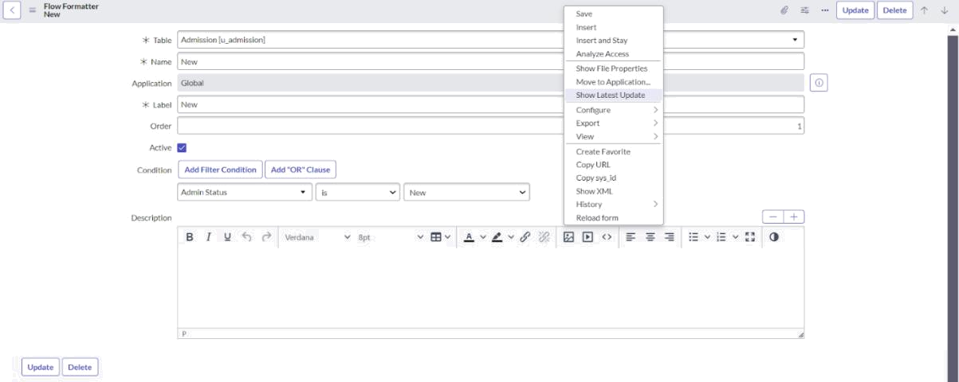

- Right Click on toggle and click on the save .

- Replace the Name and Label as below and click on Insert on stay.
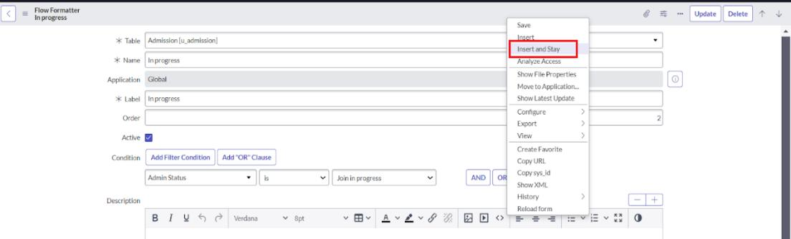

- Replace the Name and Label in order and click on Insert on stay. Joined >> Rejected >> Rejoined >> Closed >> Cancelled.

- Order should be New >> InProgress >> Joined >> Rejected >> Rejoined >> Closed >> Cancelled.

Client Script

Creating “Auto populate” Client Scripts for Admission Table

- All >> Client Scripts >> New.

- Fill the Details as given.
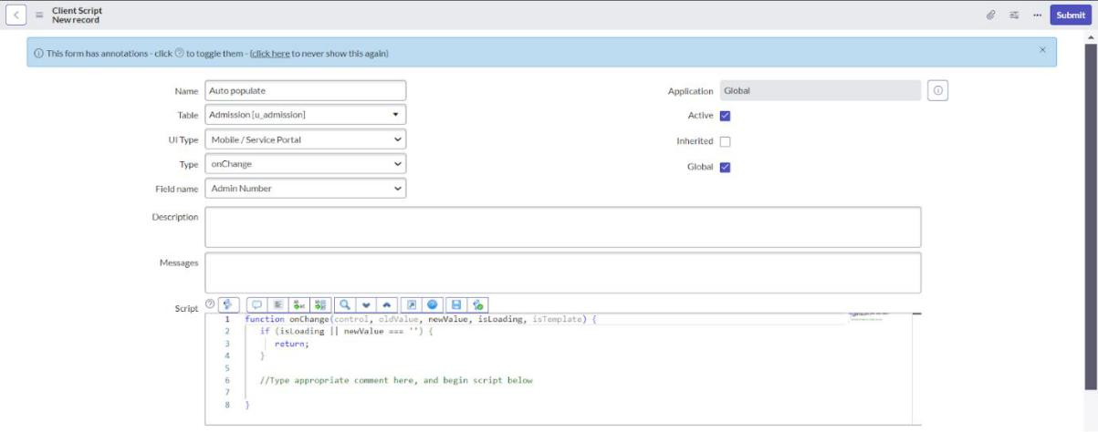

- Write the Code as below, Enable Isolate script and Save.

function onChange(control, oldValue, newValue, isLoading, isTemplate) { if (isLoading || newValue === '') {

return;

}

//Type appropriate comment here, and begin script below

var a = g_form.getReference('u_admission_number');

g_form.setValue('u_admin_date',a.u_admin_date);

g_form.setValue('u_grade',a.u_grade);

g_form.setValue('u_student_name',a.u_student_name);

g_form.setValue('u_father_name',a.u_father_name);

g_form.setValue('u_mother_name',a.u_mother_name);

g_form.setValue('u_father_cell',a.u_father_cell);
g_form.setValue('u_mother_cell',a.u_mother_cell);

g_form.setDisabled('u_admin_date',a.u_admin_date);

g_form.setDisabled('u_grade',a.u_grade);

g_form.setDisabled('u_student_name',a.u_student_name);

g_form.setDisabled('u_father_name',a.u_father_name);

g_form.setDisabled('u_mother_name',a.u_mother_name);

g_form.setDisabled('u_father_cell',a.u_father_cell);

g_form.setDisabled('u_mother_cell',a.u_mother_cell);

}

Note: Make sure the Field names should be the same as you created .

Creating “Pincode Update” Client Scripts for Admission Table

- Fill the Details as given.
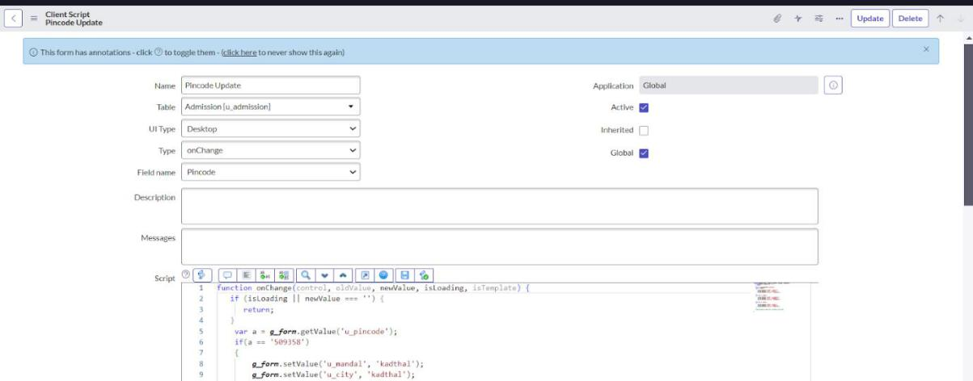

- Write the Code as below, Enable Isolate script and Save.

function onChange(control, oldValue, newValue, isLoading, isTemplate) { if (isLoading || newValue === '') {

return;

}

var a = g_form.getValue('u_pincode');

if(a == '509358')

{

g_form.setValue('u_mandal', 'kadthal');

g_form.setValue('u_city', 'kadthal');

g_form.setValue('u_district', 'RangaReddy');

}

else if(a == '500081')

{

g_form.setValue('u_mandal', 'karmanghat');

g_form.setValue('u_city', 'karmanghat');

g_form.setValue('u_district', 'RangaReddy');

}

else if(a == '500079')

{
g_form.setValue('u_mandal', 'Abids');

g_form.setValue('u_city', 'AsifNagar');

g_form.setValue('u_district', 'Hyderabad');

}

//Type appropriate comment here, and begin script below

}

Creating “Disable Fields” Client Scripts for Student progress Table

- Fill the Details as given.
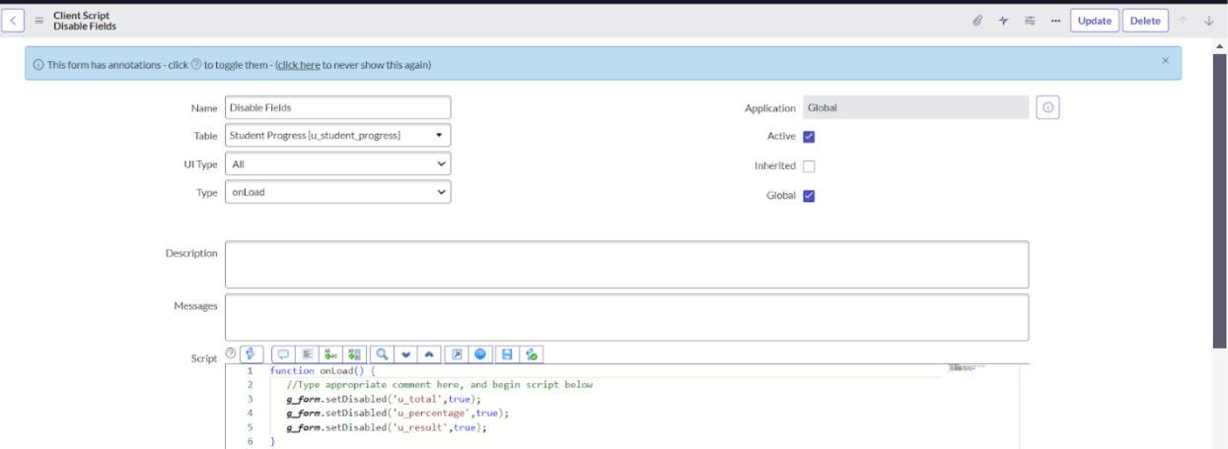

- Write the Code as below, Enable Isolate script and Save. function onLoad() {

//Type appropriate comment here, and begin script below g_form.setDisabled('u_total',true); g_form.setDisabled('u_percentage',true); g_form.setDisabled('u_result',true);

}

Creating “Total Update” Client Scripts for Student progress Table

- Fill the Details as given.
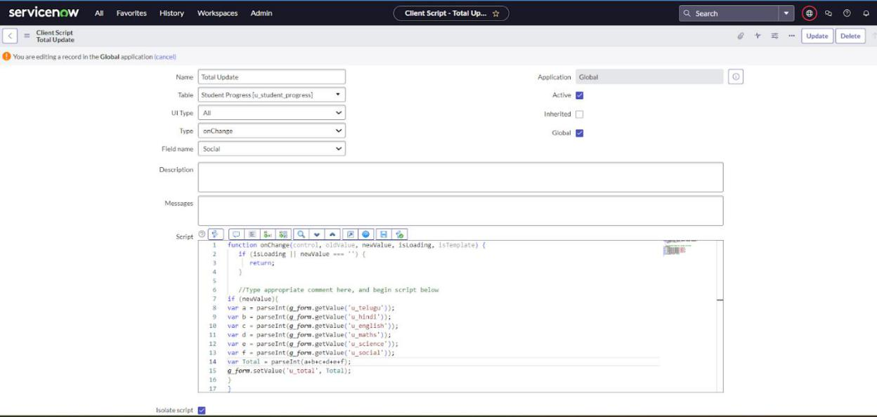

- Write the Code as below, Enable Isolate script and Save.

function onChange(control, oldValue, newValue, isLoading, isTemplate) { if (isLoading || newValue === '') {

return;

}

//Type appropriate comment here, and begin script below
if (newValue){

var a = parseInt(g_form.getValue('u_telugu')); var b = parseInt(g_form.getValue('u_hindi')); var c = parseInt(g_form.getValue('u_english')); var d = parseInt(g_form.getValue('u_maths')); var e = parseInt(g_form.getValue('u_science')); var f = parseInt(g_form.getValue('u_social')); var Total = parseInt(a+b+c+d+e+f); g_form.setValue('u_total', Total); }

}

Creating “Result” Client Scripts for Student progress Table

- Fill the Details as given.
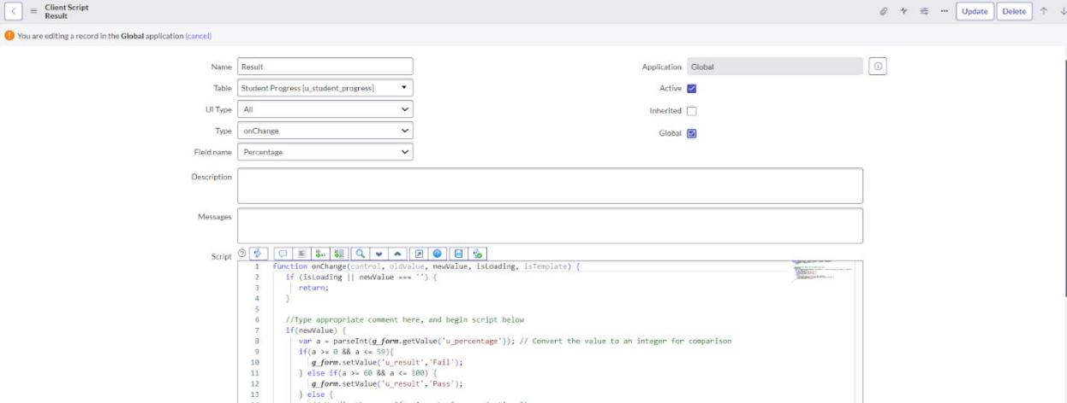
- Write the Code as below, Enable Isolate script and Save.

function onChange(control, oldValue, newValue, isLoading, isTemplate) { if (isLoading || newValue === '') {

return;

}

//Type appropriate comment here, and begin script below if(newValue) {

var a = parseInt(g_form.getValue('u_percentage')); // Convert the value to an integer for comparison

if(a >= 0 && a <= 59){

g_form.setValue('u_result','Fail');

} else if(a >= 60 && a <= 100) {

g_form.setValue('u_result','Pass');

} else {

  - Handle the case if a is out of range (optional)

g_form.addErrorMessage('Percentage should be between 0 and 100.'); g_form.clearValue('u_result');

}

}

}
Creating “Percentage” Client Scripts for Student progress Table

- Fill the Details as given.
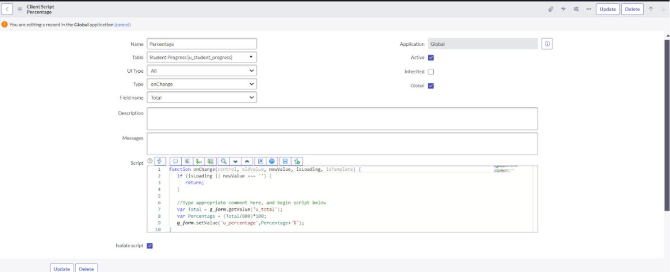

- Write the Code as below, Enable Isolate script and Save.

function onChange(control, oldValue, newValue, isLoading, isTemplate) { if (isLoading || newValue === '') {

return;

}

//Type appropriate comment here, and begin script below var Total = g_form.getValue('u_total'); var Percentage = (Total/600)*100;
g_form.setValue('u_percentage',Percentage+'%');
}

Result
